**CODING ASSIGNMENT 1**

**ME 674 SOFT COMPUTING**



# **SUBMITTED BY- ANGSHUMAN NEOGI**

**MASTER OF TECHNOLOGY**

**FLUID AND THERMAL ENGINEERING**

**INDIAN INSTITUTE OF TECHNOLOGY, GUWAHATI**

**COURSE INSTRUCTOR: PROF.SUKHOMAY PAL**

**REPORT**

**1.Introduction:**

Problem definition: Analysis and prediction of the performance of free- piston Stirling engine using response surface methodology and artificial neural network.

Background:

Free piston Stirling engine is a popular area of research in high-efficiency thermal power conversion technology. However, owing to its strong coupling, nonlinearity, and parameter interactions, building an effective model to predict the performance is of great importance. This study was to investigate and derive the prediction models of a nonlinear free-piston Stirling engine using artificial neural network. The interactive influences of thermodynamic and dynamic parameters which have significant effects on the operating frequency, and output power were illustrated.

 Five thermodynamic and dynamic parameters, including hot-end temperature, cold-end temperature, load damping, and spring stiffnesses of the displacer and piston, are selected as the input parameters, while operating frequency and output power are selected as the output parameters.

Input parameters:

|  |  |  |
| --- | --- | --- |
|  | Parameter | Unit |
| 1 | Hot end temperature | Kelvin |
| 2 | Cold end temperature | Kelvin |
| 3 | Load damping | Ns/m |
| 4 | Stiffness of displacer | N/m |
| 5 | Stiffness of piston | N/m |

Output parameters:

|  |  |  |
| --- | --- | --- |
|  | Parameter | Unit |
| 1 | Operating frequency | Hertz |
| 2 | Power Output | Watt |

Architecture of model used in published article:

-Two hidden layers with 6 and 2 neurons respectively.

No of patters available in the published article: 55.

Results from published article: About 95% of the parameters are accurately predicted by the ANN with <10% error.

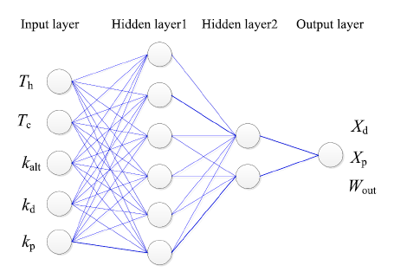

Fig-ANN with Power output

**DESIGNED ANN NETWORK(METHODOLOGY):**

While calculating the following parameters:

No. of iterations used=50000

No. of input parameters used=5

No. of output parameters used=1(Power)

Architecture of the model used:

No of hidden layers:1

Activation function in hidden layer: Log-Sigmoid function

Activation function used in output layer: Log-Sigmoid function

**1.Selection of optimum number of hidden layers:**

After checking MSE(mean squared error) values of training set for different values of M(no of hidden layers-ranging from 3 to 15), the following graph is obtained:

Therefore, optimum number of hidden layers,

M=9

**2.Selecting optimum value of learning rate:**

After checking MSE(mean squared error) values of training set for different values of eta(learning rate-ranging from 0.05 to 0.7),we found that higher range eta gives fast optimum result.

Therefore, optimum learning rate,

eta=0.6

**3.Results**

Test set MSE =0.027845485

No of iterations used=50000

The MSE value continuously decreases with the number of iteration, but the rate at which it is decreasing slows down.

Final optimum values,

M=9

eta=0.7

4.**Conclusions**

* Higher range for iteration is difficult to handle
* Final V and W are predicted nicely
* MSE of training set after 50000 iterations= in the range of 10^(-2) [changing in every run, because of random initialization of weights w and v]
* After taking the optimum values of number of hidden layers (M), learning rate (eta)), the errors (absolute error) are coming in the range of 10^(-1) to 10^(-2) in the case of output of Power
* For greater accuracy we have to consider test sets and higher no. of training patterns
* As we approximated to one hidden layer,the program is facing issues.So we have to consider 2 hidden neuron as per the research paper
* Overall, it can be said that using ANN we can very nicely formulate such real life problems and experiments.
* No.of hidden layer variations shows abrupt and erratic changes in MSE,so we have to be very careful with problem formulation.